Unit Testing Using NUnit

Introduction
In this article, I am giving a basic description about Unit testing and getting started with unit testing framework for .NET, i.e., NUnit. This article can guide from the introduction of unit testing to the tool used for unit testing.

What is Unit Testing?
Unit testing is a kind of testing done at the side of developer who develops the application. It is used to test the methods, properties, classes and assemblies. Unit testing is not the testing done by the quality assurance department. To know where unit testing fits into development, look at the following image:
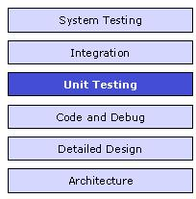
Figure: Unit Testing in Application Development
Unit testing is used to test a small piece of workable code (operational) called units. This encourages developers to modify the code without immediate concerns about how such changes might affect the functioning of other units or the program as a whole. Unit testing can be time consuming and tedious, but should be done thoroughly with patience.

What is NUnit?
NUnit is the unit testing framework for performing unit testing based on the .NET platform. It is a widely used tool for unit testing and is preferred by many developers today. Nunit is free to use. NUnit does not create any test scripts by itself. You have to write test scripts by yourself, but NUnit allows you to use its tools and classes to make the unit testing easier. The points to be remembered about NUnit are listed below:
- NUnit is not an automated GUI testing tool.
- It is not a scripting language, all test are written in .NET supported language, e.g., C#, VC, VB.NET, J#, etc.
NUnit is the derivative of the popular testing framework used by eXtreme Programming(XP). It was created by Philip Craig for .NET. Like for .NET, it is also present in the name of jUnit for java code testing.
Nunit works by providing a class framework and a test runner application. They can be downloaded from here. The class framework allows to write the test cases based on the application. The test is run using the test runner application downloaded from the above link.

Steps for using NUnit
First, what one needs to do is download the recent version of Nunit framework from the above mentioned website.
- At first, in the development studio, create a new project. In my case, I have created a console application.
- In the program.cs file, write the following code:
class Program
{
static void Main(string[] args)
{
Console.WriteLine("Enter two numbers\n");
int number1;
int number2;
number1 = int.Parse(Console.ReadLine());
number2 = int.Parse(Console.ReadLine());

MathsHelper helper = new MathsHelper();
int x = helper.Add(number1, number2);
Console.WriteLine("\nThe sum of " + number1 +
" and " + number2 + " is " + x);
Console.ReadKey();
int y = helper.Subtract(number1, number2);
Console.WriteLine("\nThe difference between " +
number1 + " and" + number2 + " is " + y);
Console.ReadKey();
}
}

public class MathsHelper
{
public MathsHelper() { }
public int Add(int a, int b)
{
int x = a + b;
return x;
}

public int Subtract(int a, int b)
{
int x = a - b;
return x;
}
}
- Then to the solution of the project, add a new class library project and name it followed by “.Test” (it is the naming convention used for unit testing). Import the downloaded DLL files into the project and follow the steps given below.
- In the newly added project, add a class and name it as TestClass.cs.
- In the class file, write the following code:
[TestFixture]
public class TestClass
{
[TestCase]
public void AddTest()
{
MathsHelper helper = new MathsHelper();
int result = helper.Add(20, 10);
Assert.AreEqual(30, result);
}

[TestCase]
public void SubtractTest()
{
MathsHelper helper = new MathsHelper();
int result = helper.Subtract(20, 10);
Assert.AreEqual(10, result);
}
}
- Now open the test runner and open the project and run it. If the test passes, then the following test screen is displayed:
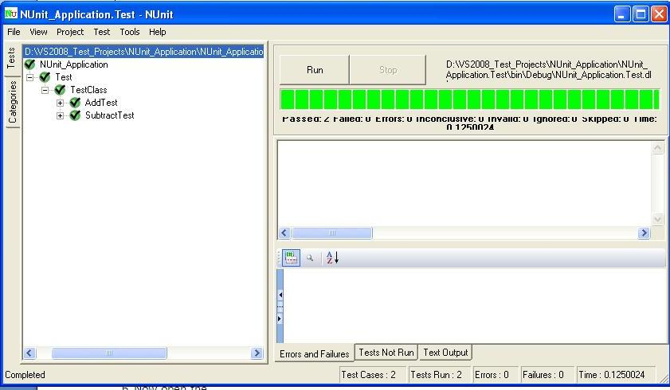
Otherwise, the following screen displays:
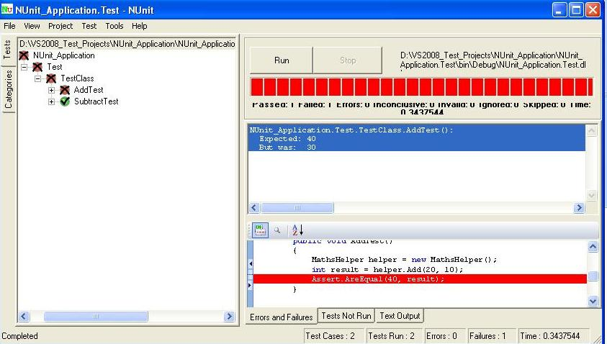

Important Attributes

1. [SetUp]
SetUp is generally used for any initialization purpose. Any code that must be initialized or set prior to executing a test are put in functions marked with this attribute. As a consequence, it avoids the problem of code repetition in each test.
[SetUp]
public void Xyz()
{
.
.
}
The code written in the Xyz method is executed before the test runs and it avoids the call of code inside this method.

2. [Ignore]
This is the attribute which is used for the code that needs to be bypassed.

3. [ExpectedException]
This attribute is used to test methods that needs to throw exception in some cases. The cases may be FileNotFoundException and others.
[Test]
[ExpectedException(typeof(MissingFileException))]
public void CheckException()
{
......
......
}
The code shouldn't have any "Assert" statement. On passing of test, the code should throw an exception, otherwise exception is not thrown.

4. [TearDown]
This is an attribute thats acts opposite of [SetUp]. It means the code written with this attribute is executed at last (after passing other lines of code). So, inside this closing is generally done, i.e. closing of file system, database connection, etc.

Mock Objects
A mock object by its name is the simulation of real object. Mock objects act just as real objects but in a controlled way. Mock object is created to test the behavior of real objects. In unit testing, mock objects are used to scrutinize the performance of real objects. Simply to say mock object is just the imitation of real object. Some important characteristics of mock object are that it is lightweight, easily created, quick, and deterministic and so on.

Stub Object
A stub object is an object which implements an interface of a component. Stub can be configured to return a value as required. Stub objects provide a valid response, but it is static nature meaning that no matter what input is passed in, we always get the same response.

Mock Object Vs Stub Object
Mock objects vary from the stub object in some ways. They are listed below:
- First distinct factor is that mock objects test themselves, i.e., they check if they are called at the proper time in the proper manner by the object being tested. Stubs generally just return stubbed data, which can be configured to change depending on how they are called.
- Secondly, mock objects are generally lightweight relative to stubs with different instances set for mock object for every test whilst stubs are often reused between tests.

using System;

namespace NUnit_Application
{
class Program
{
static void Main(string[] args)
{
Console.WriteLine("Enter two numbers\n");
int number1;
int number2;
number1 = int.Parse(Console.ReadLine());
number2 = int.Parse(Console.ReadLine());

MathsHelper helper = new MathsHelper();
int x = helper.Add(number1, number2);
Console.WriteLine("\nThe sum of " + number1 + " and " + number2 + " is " + x);
Console.ReadKey();
int y = helper.Subtract(number1, number2);
Console.WriteLine("\nThe difference between " + number1 + " and " + number2 + " is " + y);
Console.ReadKey();
}
}

public class MathsHelper
{
public MathsHelper() { }
public int Add(int a, int b)
{
int x = a + b;
return x;

}

public int Subtract(int a, int b)
{
int x = a - b;
return x;

}
}
}

using System;
using NUnit;
using NUnit_Application;
using NUnit.Framework;

namespace NUnit_Application.Test
{
[TestFixture]
public class TestClass
{
[TestCase]
public void AddTest()
{
MathsHelper helper = new MathsHelper();
int result = helper.Add(20, 10);
Assert.AreEqual(30, result);
}

[TestCase]
public void SubtractTest()
{
MathsHelper helper = new MathsHelper();
int result = helper.Subtract(20, 10);
Assert.AreEqual(10, result);
}
}
}

